Problem statement: 1. Write a program to find the highest among the given 3 numbers.

class HighestNum

{

public static void main(String[] args)

{

int a=12,b=8,c=13;//initailed 3 numbers a b c

if(a>=b) //first check to find highest number in a and b

{

if(a>=c) // second check to find highest number in a and c

System.out.println(a+ " :is the highest number");

else

System.out.println(c+ " :is the highest number");

} else {

if(b>=c) // third check to find highest number in b and c

System.out.println(b+ " :is the highest number");

else

System.out.println(c+ " :is the highest number");

}

}

}

Output:

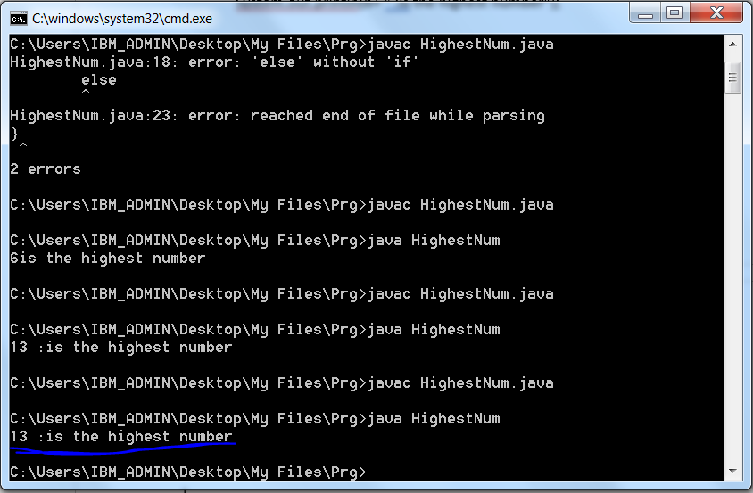

Problem 2: 2. Write a program to print the following pattern:

\* \*

\* \*

\*

\* \*

\* \*

import java.util.Scanner;

class PrintStar

{

public static void main(String[] args)

{

Scanner s=new Scanner(System.in); //input number from keyboard

System.out.println("Enter the number of rows=column");

int n=s.nextInt(); //nextInt() method from Scanner class to select next token which is int.

int i,j;

s.close(); //close the scanner class

for(i=1;i<=n;i++) //consider this as a row

{

for(j=1;j<=n;j++) // consider this as a column

{

if(j==i) { //if both column and row has same value then print \*

System.out.print("\*");

}

else if(j==n-(i-1)) // to print \* in oppsite compared to above line

{

System.out.print("\*");

}

else {

System.out.print(" ");} // print blank if above condition is false

}

System.out.println(); // to place cursor in next line

}

}

}

Output:-

